CPE301 – SPRING 2019

Design Assignment 4A

Student Name: Saul Alejandro Mendoza Guzman

Student #: 2000540481

Student Email: mendos1@unlv.nevada.edu

Primary Github address: https://github.com/mendos1/subnission_da

Directory: DA4A

Submit the following for all Labs:

1. In the document, for each task submit the modified or included code (only) with highlights and justifications of the modifications. Also, include the comments.
2. Use the previously create a Github repository with a random name (no CPE/301, Lastname, Firstname). Place all labs under the root folder ESD301/DA, sub-folder named LABXX, with one document and one video link file for each lab, place modified asm/c files named as LabXX-TYY.asm/c.
3. If multiple asm/c files or other libraries are used, create a folder LabXX-TYY and place these files inside the folder.
4. The folder should have a) Word document (see template), b) source code file(s) and other include files, c) text file with youtube video links (see template).

1. **COMPONENTS LIST AND CONNECTION BLOCK DIAGRAM w/ PINS**

For this assignment I used the following components:

* + Atmega328p Xplained MINI
  + Multi-Functioin Shilde for Arduino
  + MD08A Motor Driver
  + Breadboard
  + 10 wires
  + Potentiometer
  + External power supply (+5V)
  + USB cable for Atmega328p
  + Atmel Studio 7.0

1. **INITIAL/MODIFIED/DEVELOPED CODE OF TASK 1/A**

#define *F_CPU* 16000000UL // 16MHz

#include <avr/io.h> //

#include <avr/interrupt.h> //

#include <util/delay.h> //

void init_adc(void);

int control; // VARIABLE FOR ADC VALUE (NOT NEEDED)

int toggle = 0; // USED TO DETERMINE IF BUTTON SHOULD BE ON OR OFF

int main()

{

DDRD = 0x40; // MAKES PD6 AS PWM OUTPUT

DDRB |= (1<<2); // THIS IS JUST AN LED INDICATOR ON THE MULTIFUNCTION SHILED

PORTB |= (1<<2); // THIS TURNS IT ON/OFF

DDRC = 0x02; // SET PC0 AS INPUT AND PC1 AS OUTPUT FOR INTERUPTS , LEAVE INT1(PD3) AS INTERRUPT

PORTC |= (1<<1); // ENABLE PULL-UP RESISTOR

TCCR0A=0x83; // FAST PWM // CLEAR OCR0A ON MATCH

TCCR0B=0x05; // SET PRESCALAR TO 1024

PCICR = 0x02; // 0x02 IS PCIE1, THAT IS, ENABLE PCIE1 FOR PCMSK1 TO WORK

//PCIFR = 0x02; // ENABLE PCIF1 INTERRUPT FLAG

PCMSK1 = 0x02; //ENABLE PIN CHANGES ON PCINT9 (PC1)

sei(); // GLOBAL INTERRUPTS ENABLED

ADMUX = (1<<REFS0); // REFERENCE VOLTAGE AT AREF

ADCSRA = (1<<ADEN)|(1<<ADSC)|(1<<ADATE)|(1<<ADPS2)|(1<<ADPS1)|(1<<ADPS0);

while (1){}

}

ISR(PCINT1_vect){

if(!(PINC & (1<<PINC1))){

if(toggle == 0){

OCR0A = 0;

PORTB &= ~(1<<PORTB2);

*_delay_ms*(1000);

}

if (toggle == 1){

while((ADCSRA&(1<<ADIF))==0); // wait for conversion

control = ADC; // ADC Conversion

OCR0A = control; // Output to converted value to 0CR0A

PORTB |= 1 << PORTB2;

*_delay_ms*(1000);

}

toggle ^= 1; //update state of motor to on

}

}

1. **SCHEMATICS**

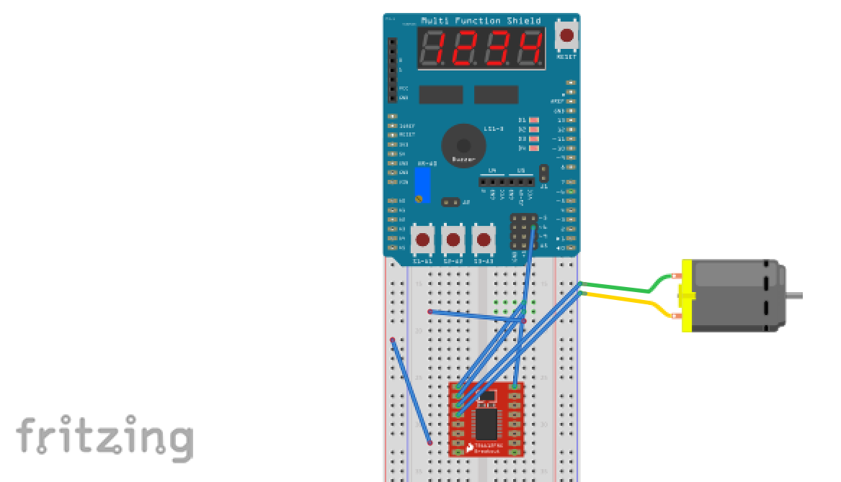

1. **SCREENSHOTS OF EACH TASK OUTPUT (ATMEL STUDIO OUTPUT)**
2. **SCREENSHOT OF EACH DEMO (BOARD SETUP)**

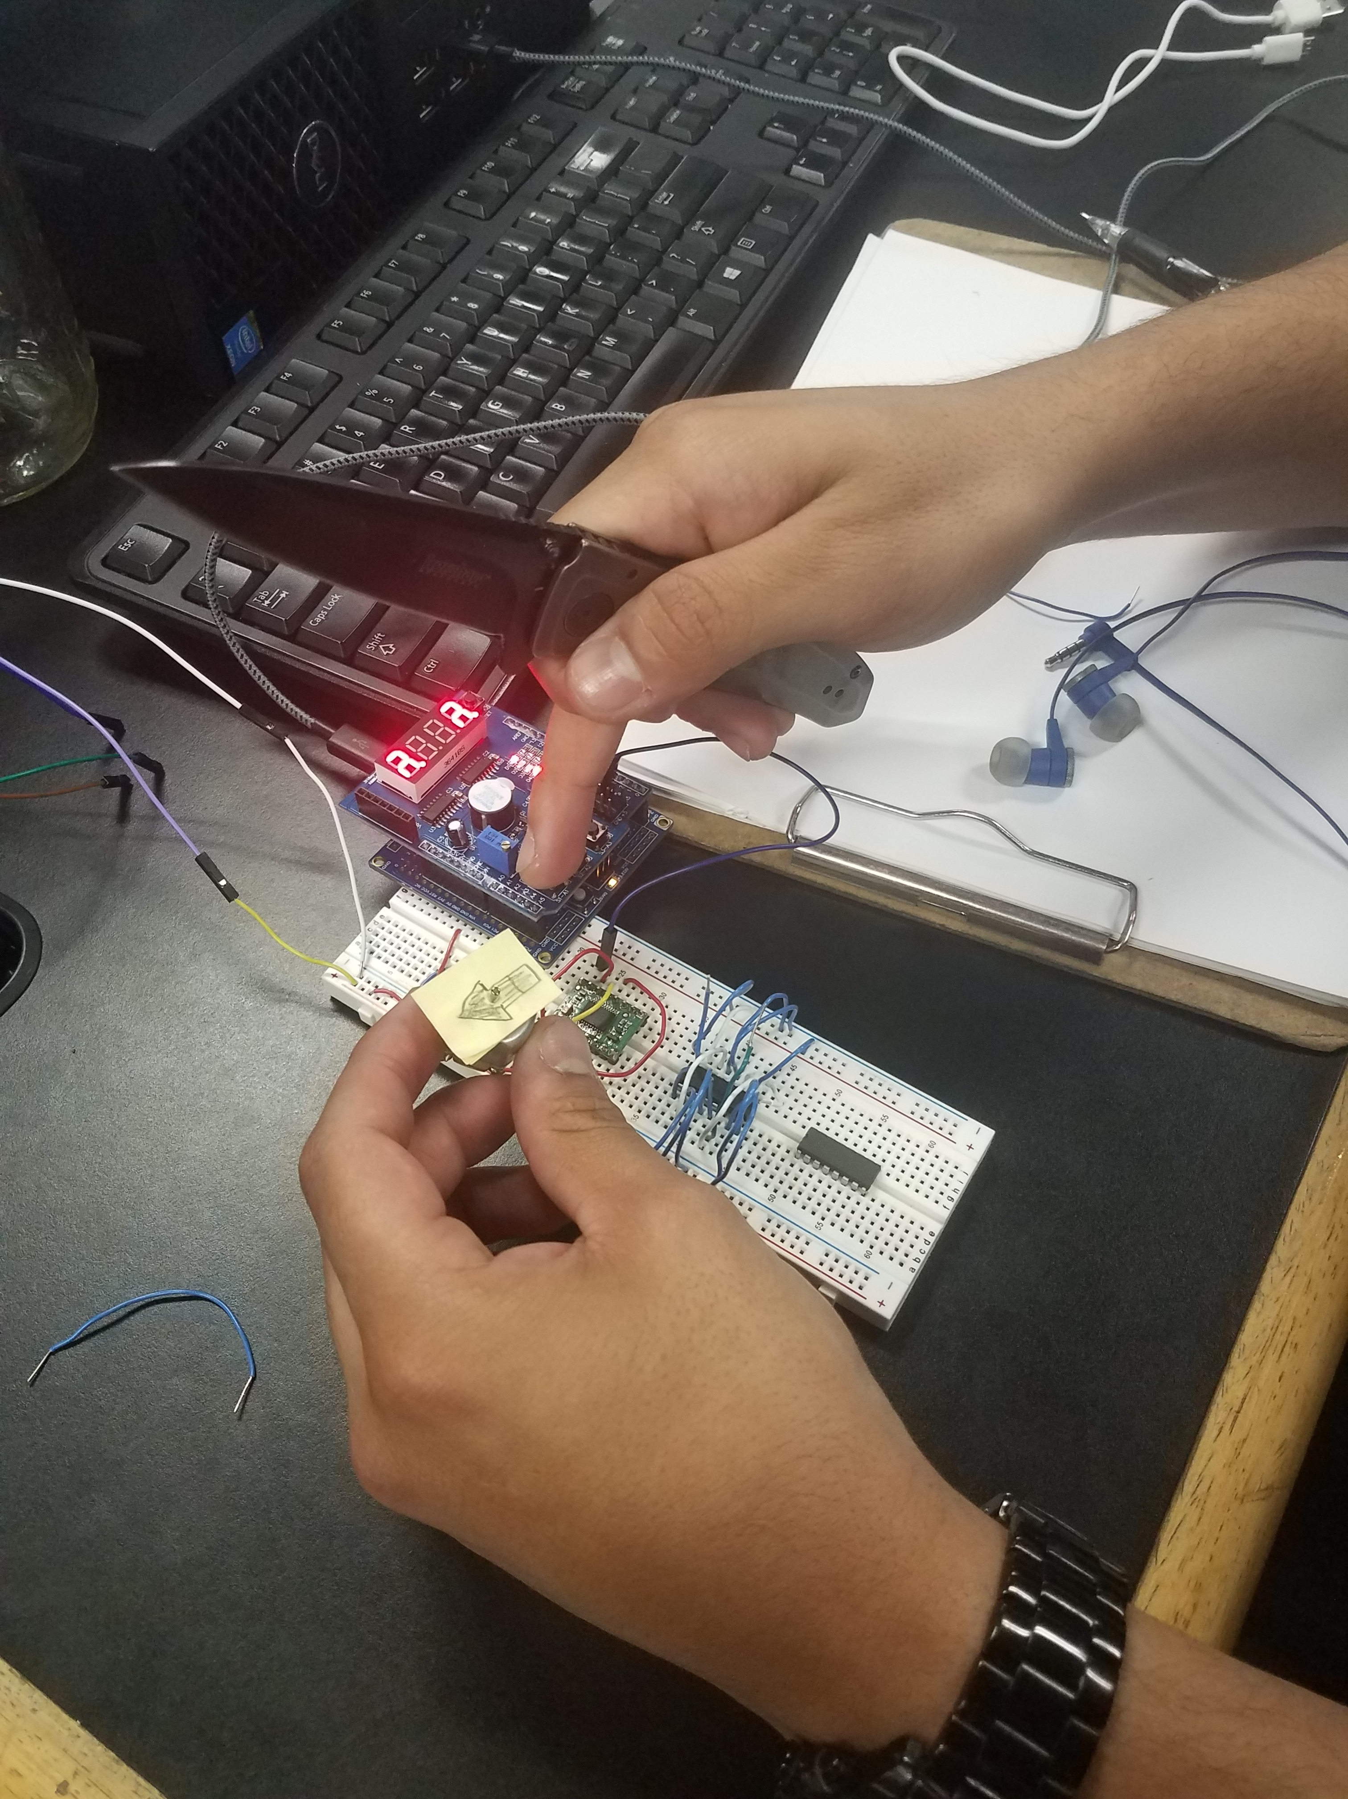

1. **VIDEO LINKS OF EACH DEMO**

https://www.youtube.com/watch?v=zP2bg6LImpA

1. **GITHUB LINK OF THIS DA**

<https://github.com/mendos1/subnission_da/DA4A>

**Student Academic Misconduct Policy**

<http://studentconduct.unlv.edu/misconduct/policy.html>

“This assignment submission is my own, original work”.

NAME OF THE STUDENT